Laser Rigging Basics

St. Jamestown Sailing Club

This rigging guide is intended as a reference of Laser rigging “best practices”. It is not a substitute for personal instruction and you should attend a Laser clinic that covers rigging and boat handling before attempting to rig and sail a Laser.

- After signing out your laser, position your boat to rig on-land (bow facing into the wind). Before starting to rig, you should gather the following items:
- Mast (top and bottom)
- Boom
- Mainsail
- 3 Lines: outhaul (long), cunningham (medium), clew tie-down (short). Main-sheet and boom vang are attached to boom and mast.
- Rudder
- Rudder tiller and extension
- Daggerboard
- Paddle
- PFD

- Install the buoyancy tank plug.
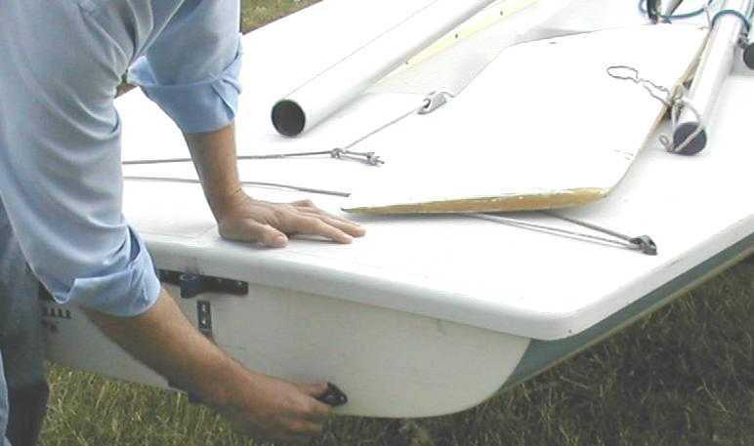

- Assemble the mast. Align the rivet(s) found on the bottom part of the mast top with the gooseneck. This increases the support strength along the mast top.
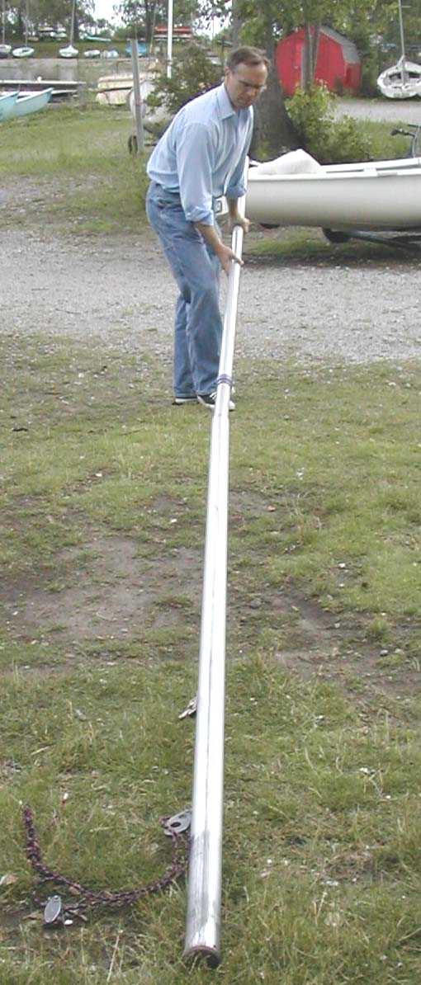

- Unfold the sail and slide the sail mast sleeve over the top of the mast. Align the very top of the mast sleeve with the gooseneck.
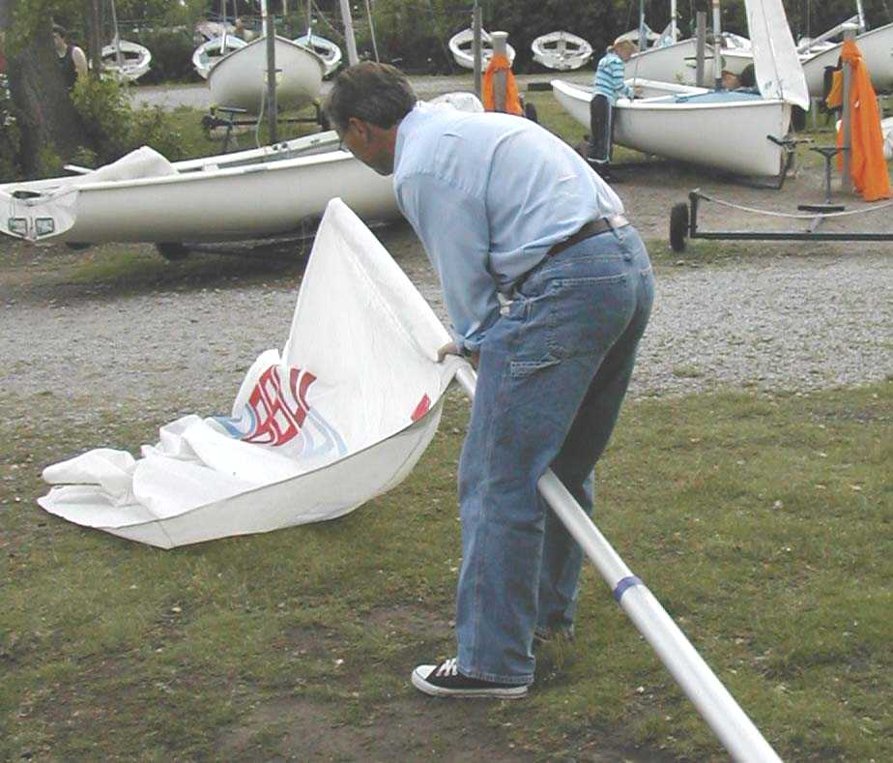

- Install sail battens.
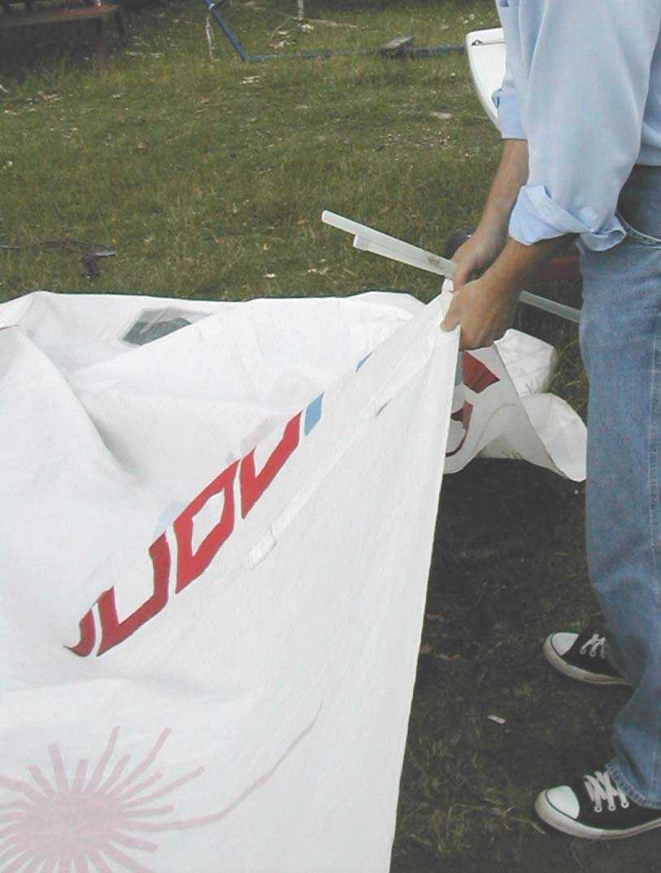

- Grasping the mast low, lift and insert the lower mast all the way into the mast step. Gently lower the mast into the step.
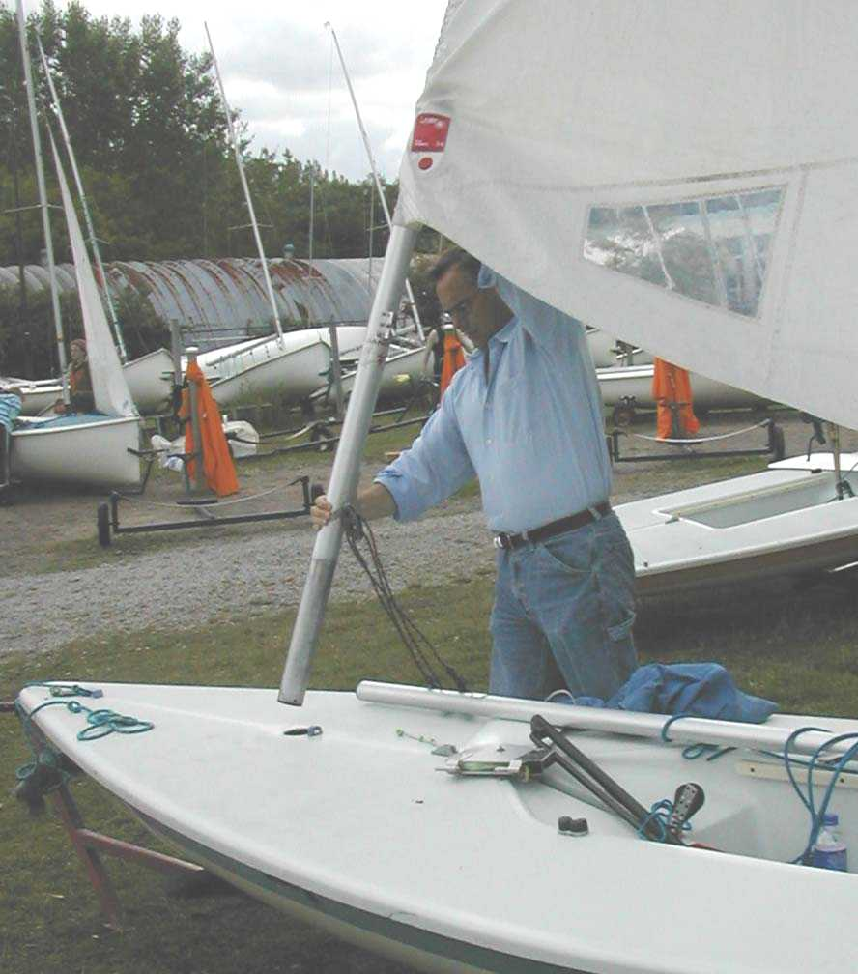

- Feed the outhaul line through the outhaul fairlead, through the clew grommet in the sail, back through the outhaul fairlead and then fasten it to the clew grommet with a bowline. Run the other end of the outhaul through the jamb cleat in the middle of the boom. Once fastened, you have two free hands to attach the boom to the gooseneck.
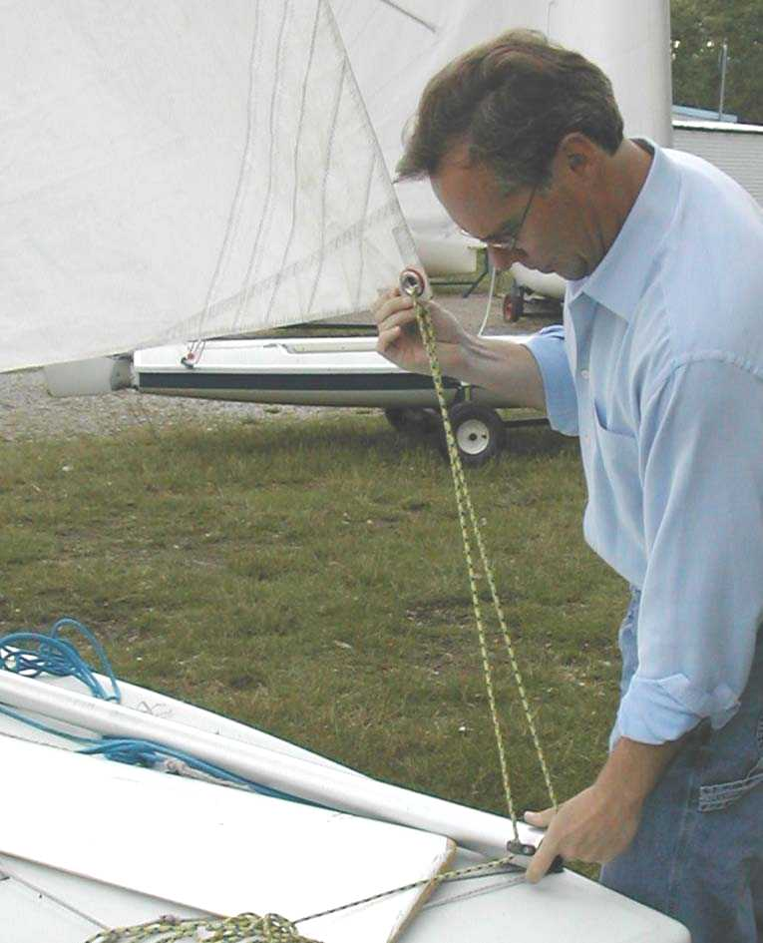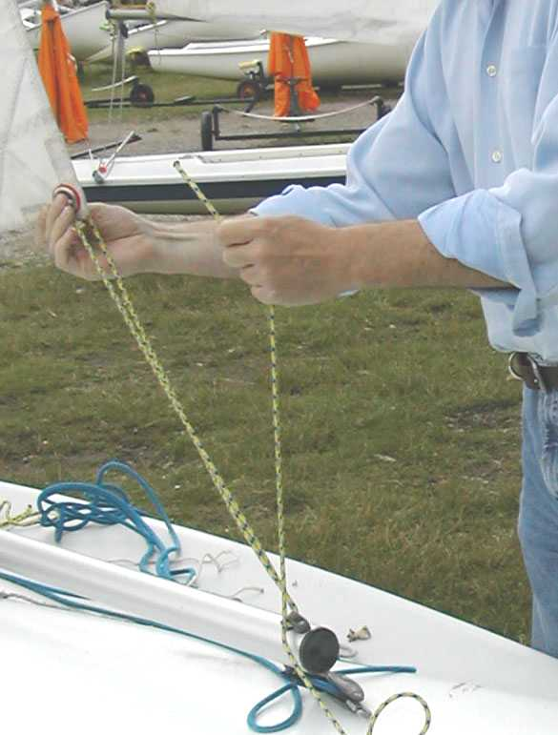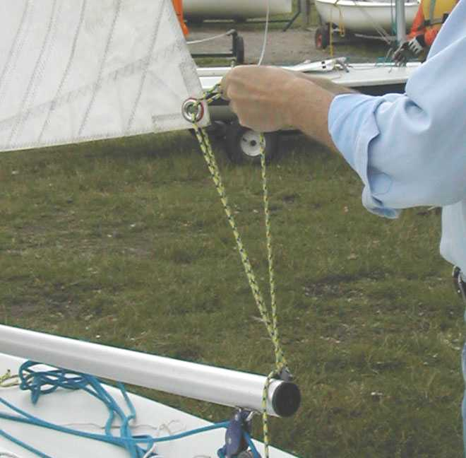

- Attach the boom to the mast by inserting the gooseneck pin into the forward end of the boom.
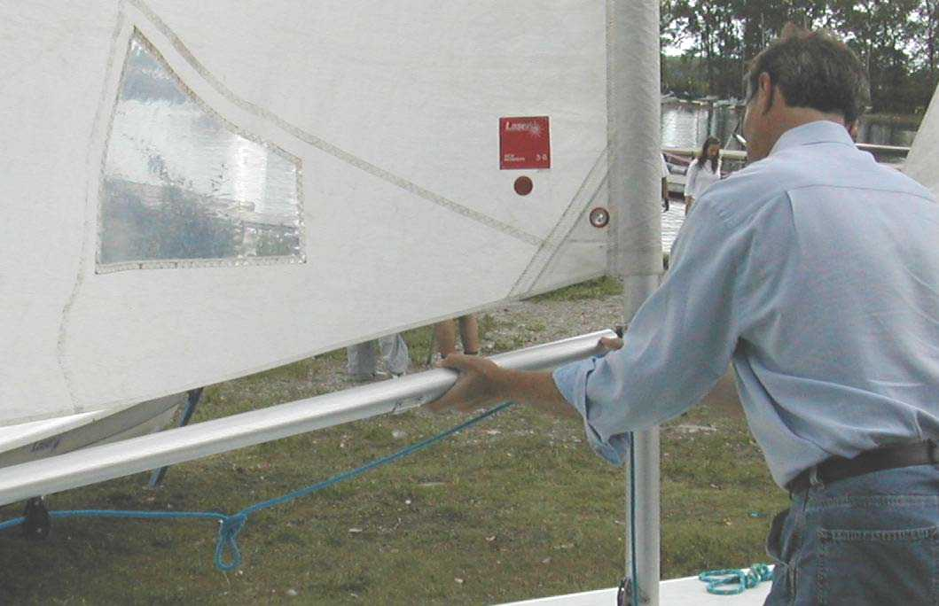

- On the forward end of the outhaul jamb cleat, make a “trucker’s hitch”.
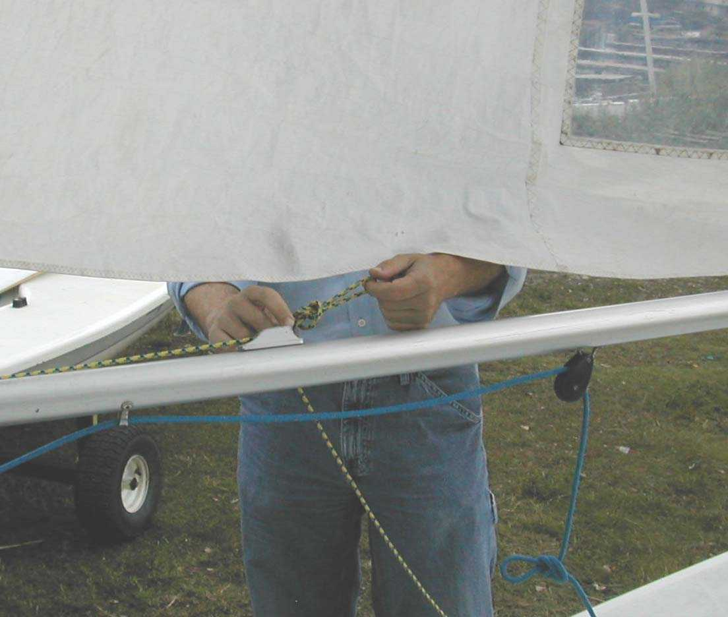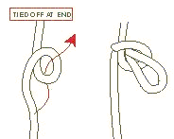

- Pass the outhaul line around the mast and make another trucker’s hitch.
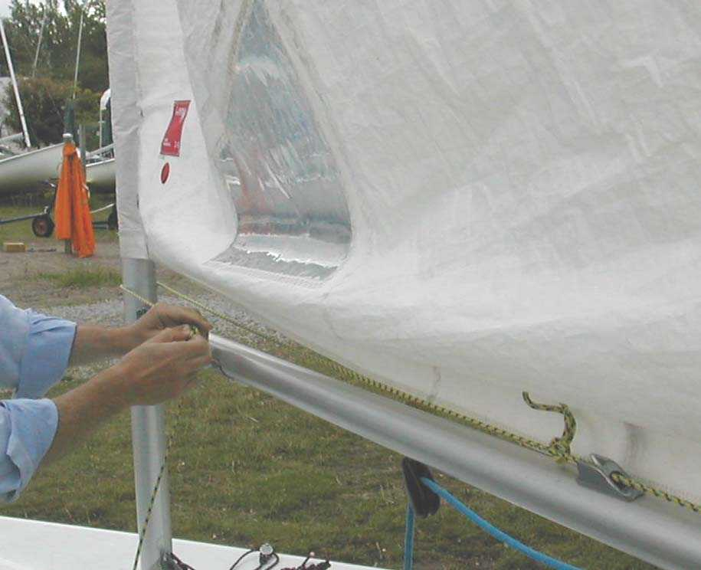

- Pass the outhaul line back through the first trucker’s hitch and then forward through the second trucker’s hitch. Form a loop in the end of the outhaul line that will serve as a handle for the outhaul line.
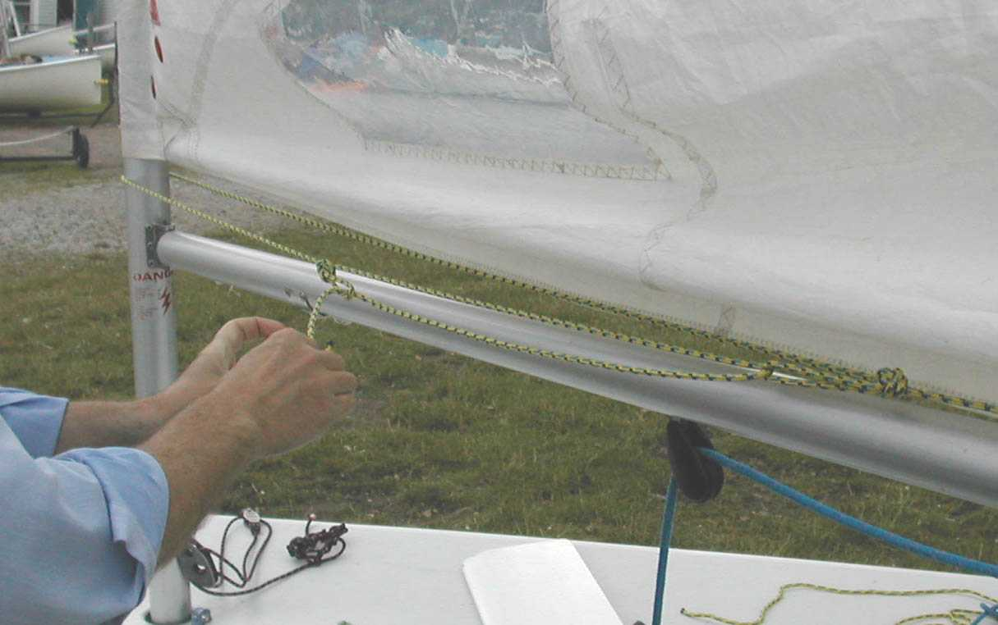
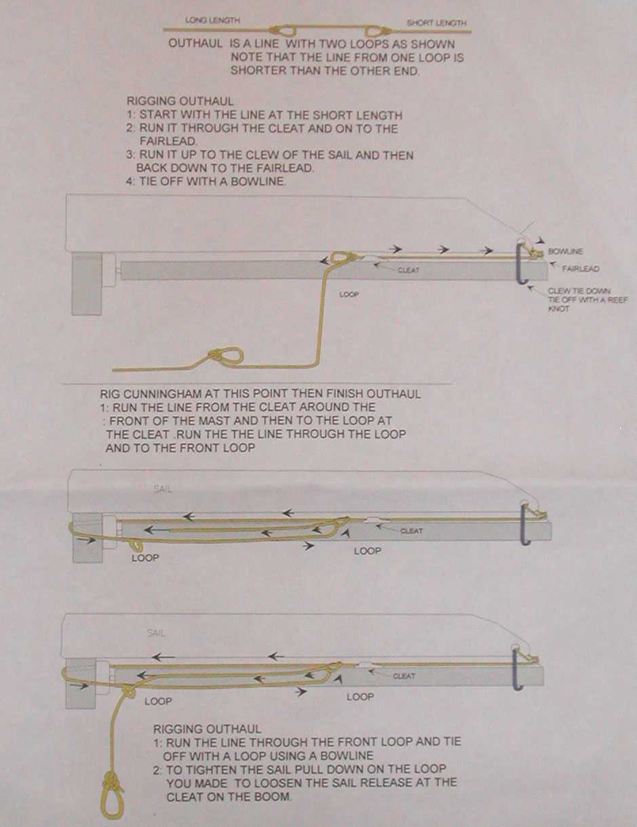
(Rigging diagram courtesy of Westwood Sailing Club)

- Tie the clew down to the boom using a reef knot.
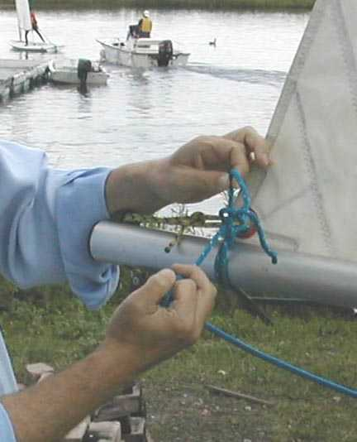

- The cunningham attaches to the boom-vang tang (end with a short line to the trucker’s hitch). Feed the Cunningham through the tack grommet and form a second trucker’s hitch. Feed the cunningham down through the first trucker’s hitch, back up through the second trucker’s hitch. Feed the cunningham down through the cunningham fairlead at the base of the mast and then through the cunningham jamb cleat towards the cockpit. Finish the end of the line with a figure-eight knot (Note: This eight-knot is essential. When the boat turtles, this knot prevents the rig from coming completely out of the boat).
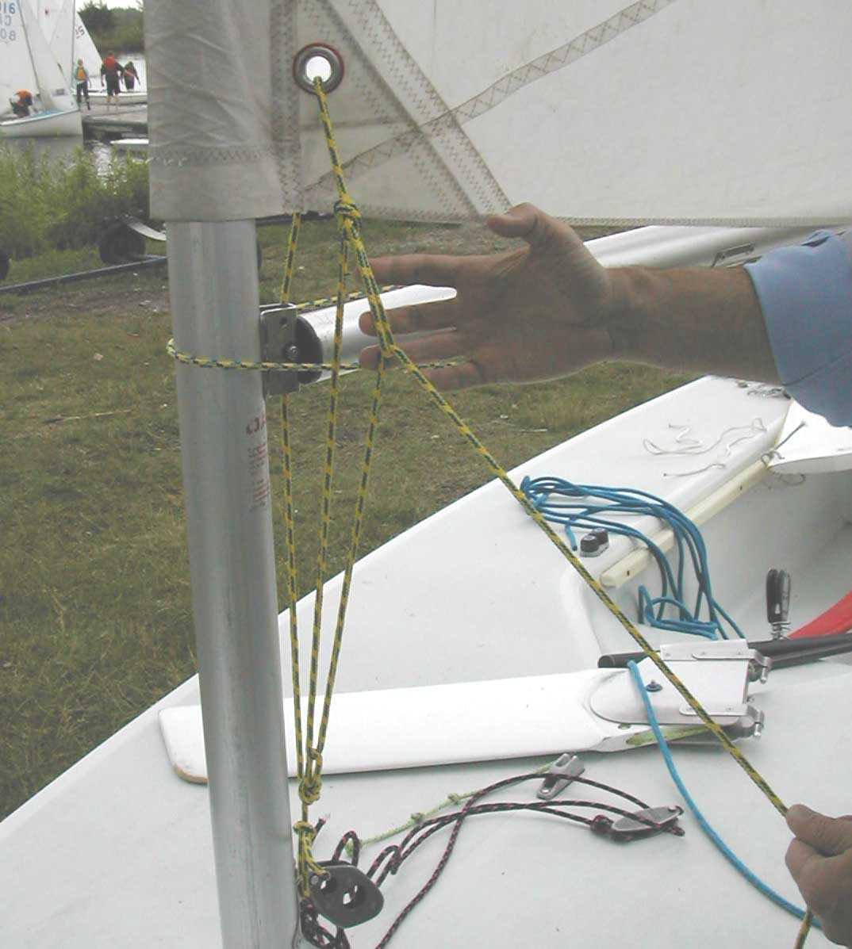
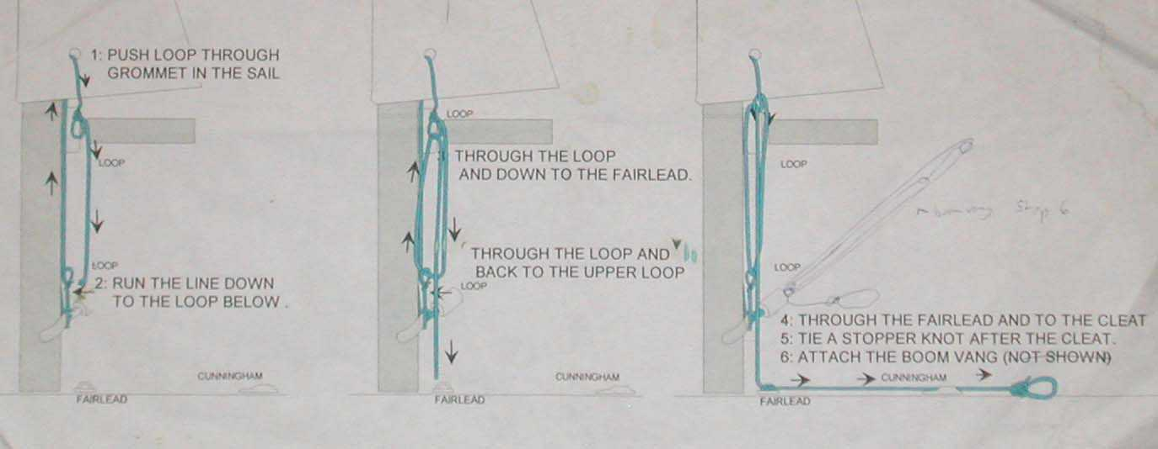
(Rigging diagram courtesy of Westwood Sailing Club)

- Install the rudder by sliding the pintles into the gudgeons until the rudder lift stop snaps into place.
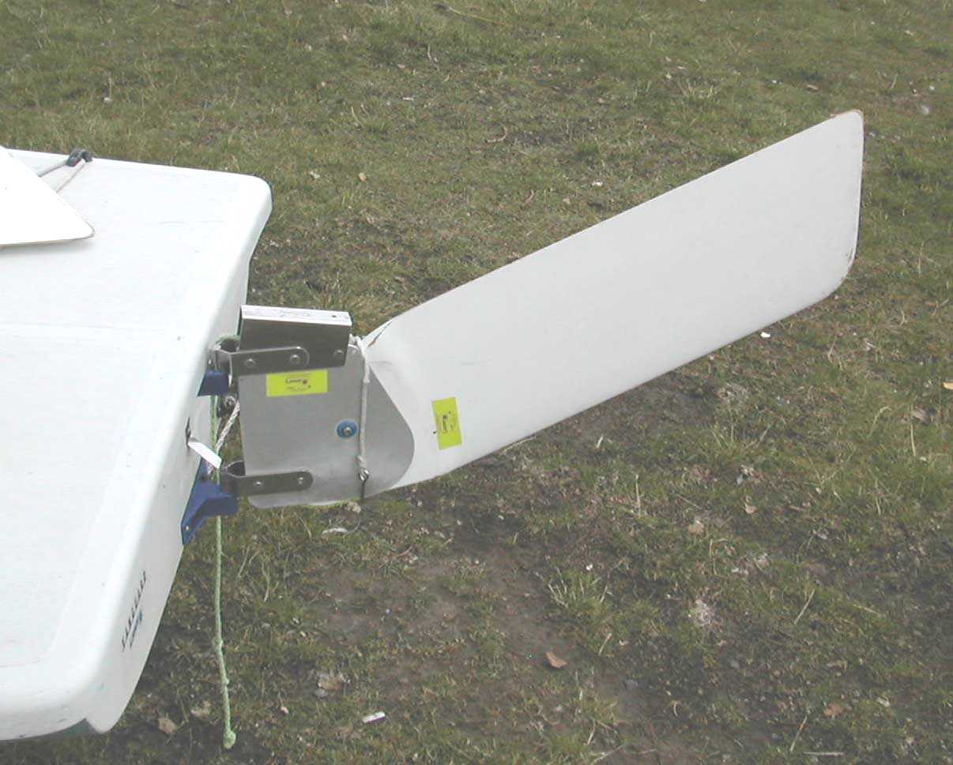

- Slide the tiller into the rudder head and insert the retaining pin. Note that the tiller passes under the traveller line. Make sure that the traveller is tight. The portion of the traveller crossing over the tiller extension should be tight enough to produce a light “ping” when plucked. This tension ensures that the (mainsheet) traveller blocks travel to the corner of the traveller and not ride along in the middle. When the blocks are in the corner, the boat will gather speed (when close-hauled). If the blocks ride in the middle, the boat will be slow.
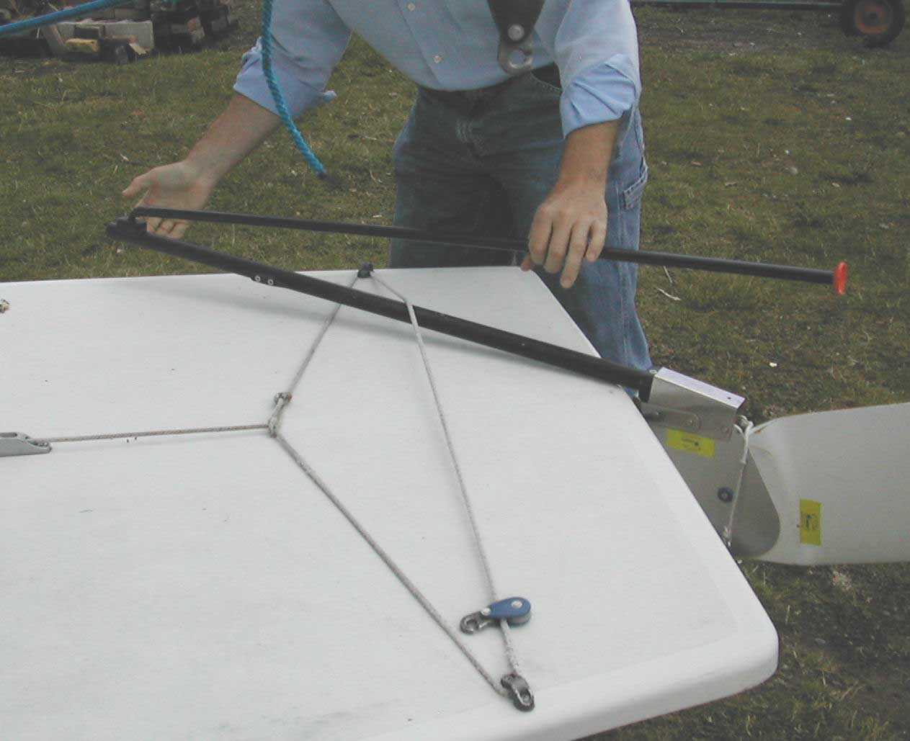

- Launch the boat.

- Attach the boom vang to the boom.
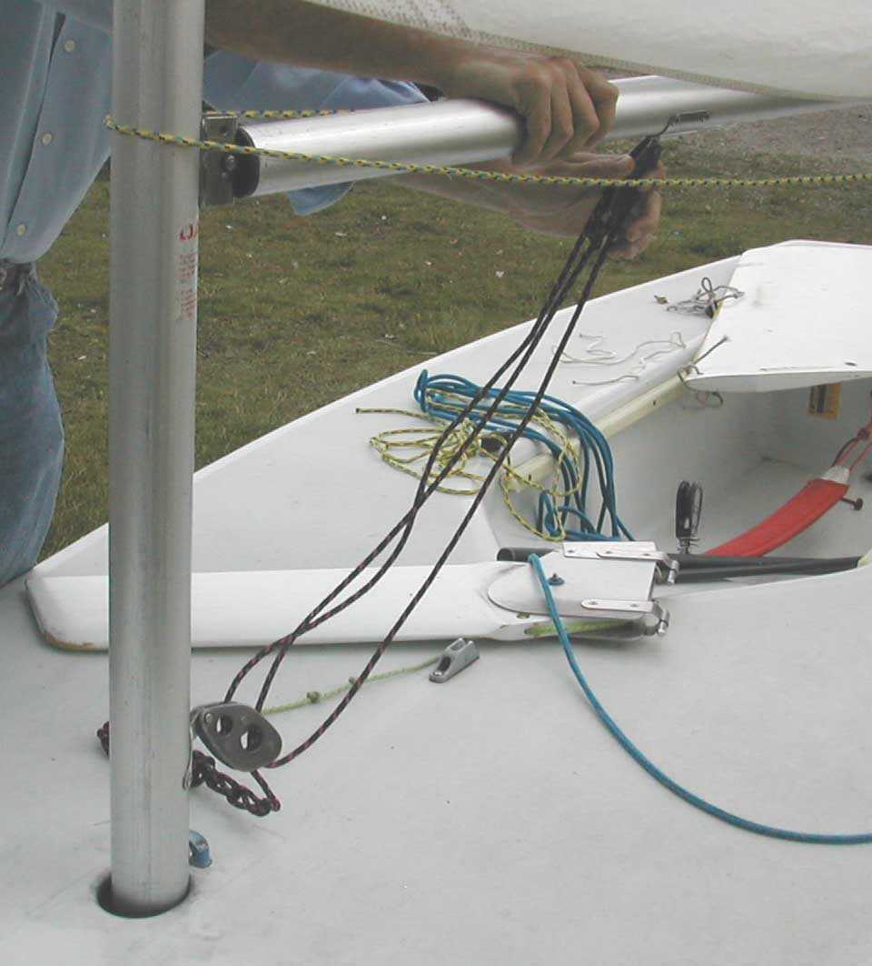

- Lower the rudder into position and cleat the line.
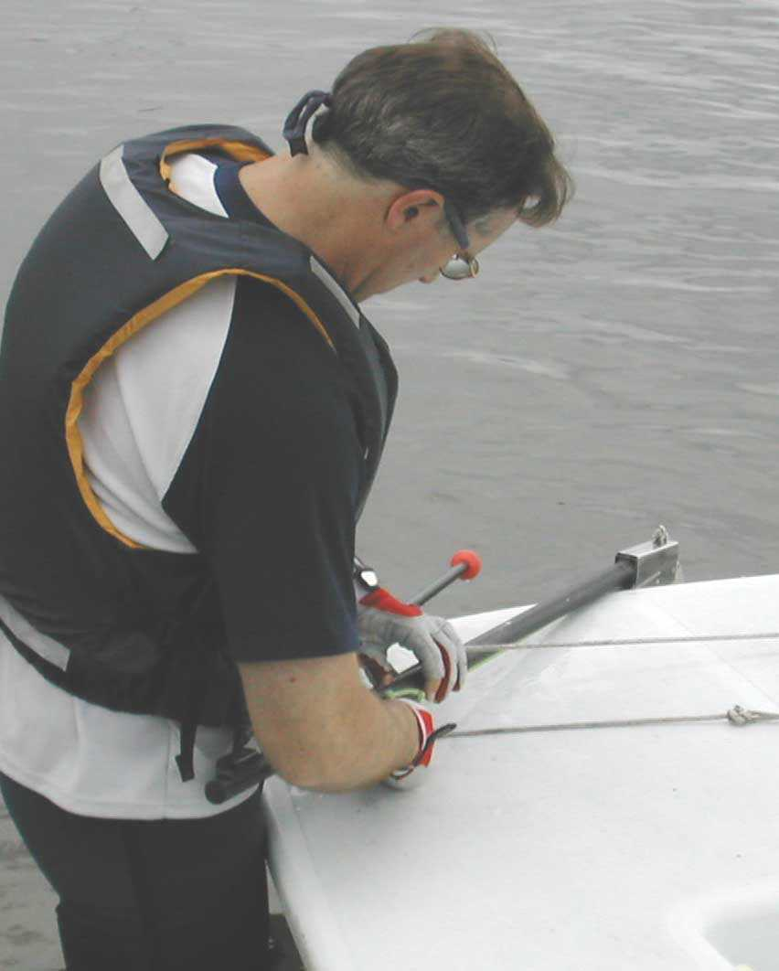

- Insert the dagger-board into the dagger-board slot. Run the tension-cord forward through the bow-eye and back to the dagger-board (or mast).
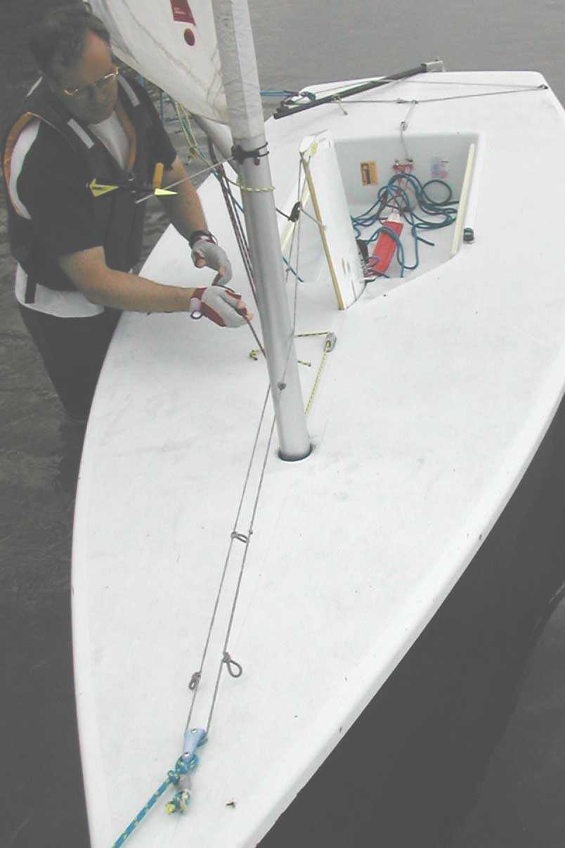

- Connect the traveller blocks.
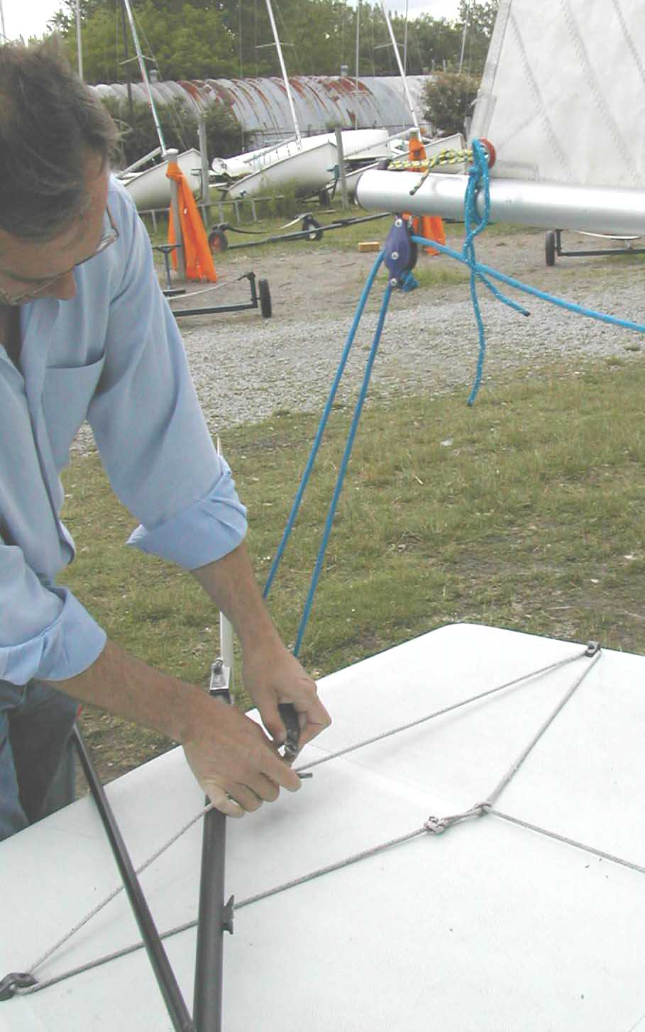

- Attach the oar to the boat (usually around the mast).

- Take your PFD, cast off and enjoy your sail.

- To de-rig the laser, repeat steps 1-21 in reverse order.

- When stowing the sail, fold it (don’t roll the sail) such as to avoid forming a crease in the sail window. A creased window will result in a crack and eventual breach in the window.


